Airtel

Deployment Configuration
EAI ABTS Application

Version 0.1
Approved by:

.
Security: IBM Confidential

Document History

Version | Date | Author | Notes
V0.1 | 05/07/2010 | Prameela Rani Yerra | Initial draft

Table of Contents
1 Document History 2
2 Introduction 4
2.1 Purpose 4
2.2 Scope 4
2.3 Acronyms 4
3 SOA integration Solution 5
Fig. ESB Architecture Overview Diagram 5
4 EAI ABTS Deployment Configuration 6
4.1 Names and Descriptions 6
4.2 Nodes and Software Components 8
4.3 Clusters and Queue Managers 8
4.4 Hardware clustering (HACMP) 9
4.5 Web Sphere MQ Configuration 10
4.6 Database Configuration 11
4.7 Configuration Manager Setup for Message Brokers 11
4.8 Message Broker Configuration 11
4.9 WBI Adapters Configuration 13
4.9.1 WBI Adapter configuration and installation 14
4.9.2 WBI Adapter Queue Manager and Queue Details 14
4.9.3 Installation and Configuration Details 16
4.9.4 Changes in script files 16
4.9.5 Changes in Adapter config file 16
4.9.6 Adapter Related Files 16
4.9.7 Back-end Production System Details: 17
4.9.8 Operational Handling of WBI Adapters 17
4.9.9 Scripts: 19
5 References 20

Introduction

Purpose
As part of EAI Phase II transformation project for Bharti, SOA integration solution has been implemented by IBM to support integration, virtualization, and management of service interactions between communicating participants. The goal of EAI Phase II project in Bharti environment is to provide connectivity among various systems and applications and facilitates interactions between them.

The purpose of this document is to outline the deployment configuration for proposed EAI Phase II transformation project.

Scope

The scope of this document is limited to deployment configuration for proposed EAI Phase II transformation project. This document doesn’t cover implementation, or design details of the systems in EAI Phase II transformation project.

Acronyms

Acronym | Expansion
Bharti | Bharti Tele-Ventures Limited
LOB | Line Of Business
EAI | Enterprise Application Integration
ESB | Enterprise Service Bus
SOA | Service Oriented Architecture
WMB | WebSphere Message Broker
WBIA | WebSphere Business Integration Adapter
WMQ | WebSphere Message Queue
SC | Selfcare
ABTS | Airtel Broadband & Telephone Services
AES | Airtel Enterprise Services
LDS | Long Distance Services
DTH | Direct To Home

SOA integration Solution
The following diagram depicts the SOA integration solution implemented at Bharti environment as part of EAI transformation project as a whole. The applications and various core systems in Bharti environment will be integrated using ESB and adapters.

Please refer to ESB Technical Architecture document for more details on EAI solution.

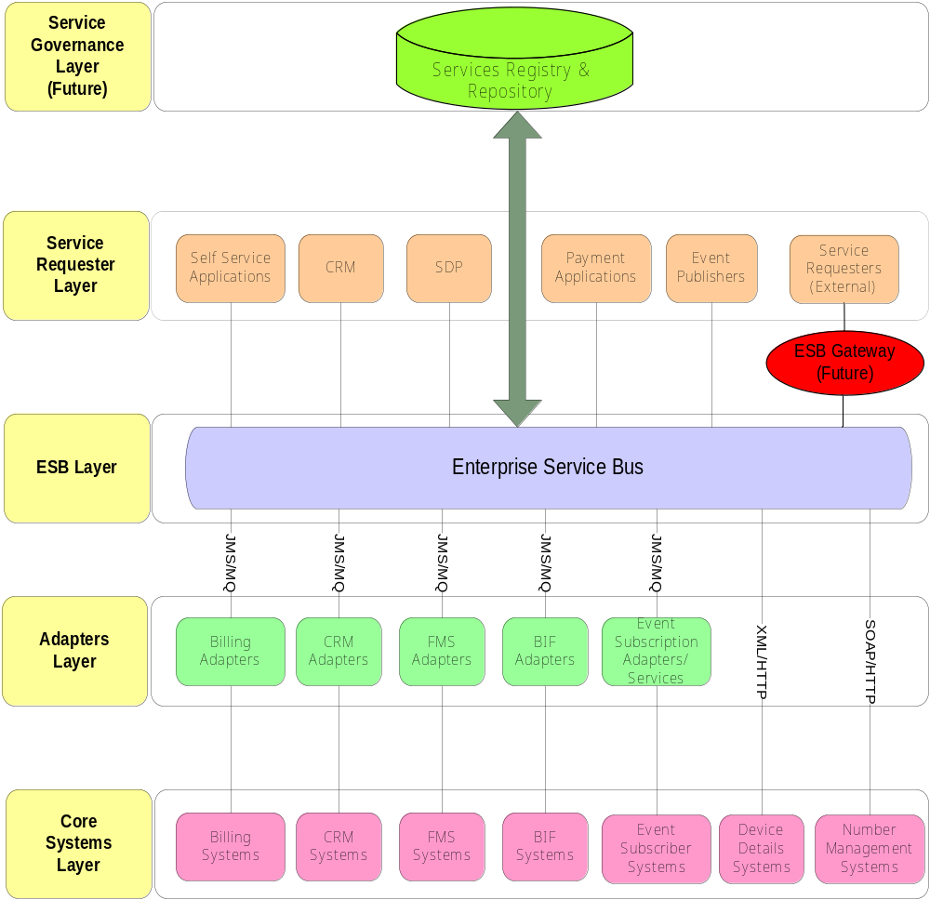
Enterprise Security Management
Enterprise Systems Management

Fig. ESB Architecture Overview Diagram

EAI ABTS Deployment Configuration

The following diagram describes deployment configuration for ABTS project in the Bharti environment from a hardware/software allocation perspective.

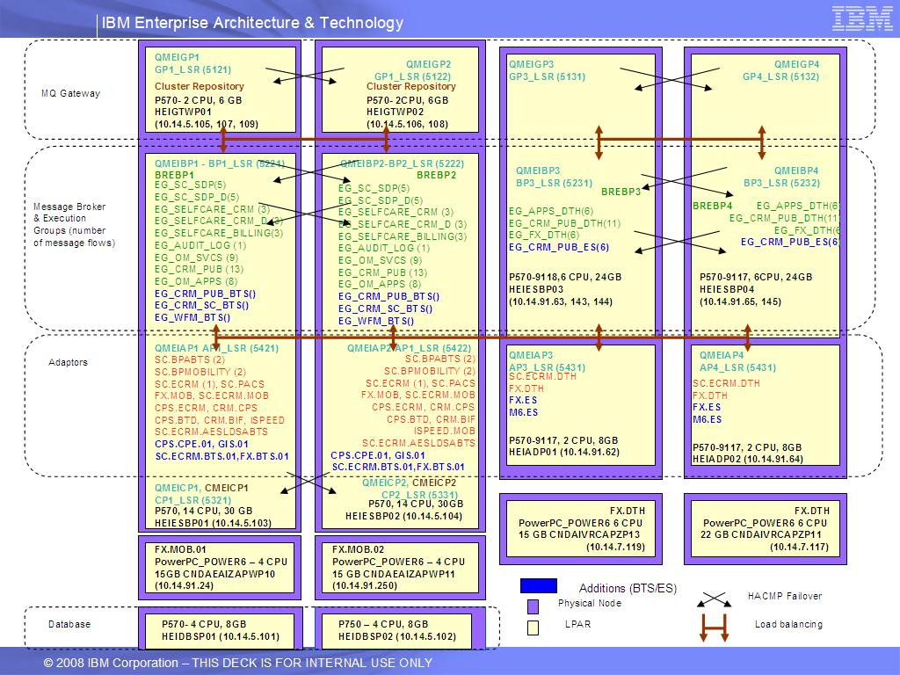

Names and Descriptions
The following table describes the names that were used to specify the deployment configuration. The same stack is being used for ABTS also.

Names Descriptions
S.No | Name | Description | Remarks
1 | HEIGTWP01 | The node that hosts Gateway queue manager 1
2 | HEIGTWP02 | The node that hosts Gateway queue manager 2
3 | HEIESBP01 | The node that hosts Broker ( BREIBP1), Configuration manager(CMEICP1), Adapter Queue Manager (QMEIAP1)
4 | HEIESBP02 | The node that hosts Broker ( BREIBP2), Configuration manager(CMEICP2), Adapter Queue Manager (QMEIAP2)
5 | HEIESBP03 | The node that hosts Gateway queue manager 3, Broker ( BREIBP3), Configuration manager(CMEICP2)
6 | HEIESBP04 | The node that hosts Gateway queue manager 4, Broker ( BREIBP4)
7 | HEIDBSP01 | The node that hosts database servers for Brokers BREIBP1 BREIBP2, BREIBP3, BREIBP4 and application database BREIAP1
8 | HEIDBSP02 | The node that hosts database servers for Brokers BREIBP1 BREIBP2, BREIBP3, BREIBP4 and application database BREIAP1 (Failover)
9 | HEIADP01 | The node that hosts Adapter Queue Manager (QMEIAP3)
10 | HEIADP02 | The node that hosts Adapter Queue Manager (QMEIAP4)
1 | QMEIGP1 | Gateway queue manager 1
2 | QMEIGP2 | Gateway queue manager 2
3 | QMEIGP3 | Gateway queue manager 3
4 | QMEIGP4 | Gateway queue manager 4
5 | QMEICP1 | Configuration Manager Queue Manager
6 | QMEICP2 | Configuration Manager Queue Manager
7 | QMEIBP1 | Broker queue manager 1
8 | QMEIBP2 | Broker queue manager 2
9 | QMEIBP3 | Broker queue manager 3
10 | QMEIBP4 | Broker queue manager 4
11 | QMEIAP1 | Adapter queue manager 1
12 | QMEIAP2 | Adapter queue manager 2
13 | QMEIAP3 | Adapter queue manager 3
14 | QMEIAP4 | Adapter queue manager 4
1 | BREIBP1 | BROKER 1 hosted on node HEIESBP01
2 | BREIBP2 | BROKER 2 hosted on node HEIESBP02
3 | BREIBP3 | BROKER 3 hosted on node HEIESBP03
4 | BREIBP4 | BROKER 4 hosted on node HEIESBP04
5 | CMEICP1 | Configuration Manager 1
6 | CMEICP2 | Configuration Manager 2
17 | ADAPTERS1 | Set of adapters hosted on HEIESBP01 with QMEIAP1 as their queue manager
18 | ADAPTERS2 | Same Set of adapters hosted on HEIESBP02 with QMEIAP2 as their queue manager
19 | ADAPTERS3 | Same set of adapters hosted on HEIAP01 with QMEIAP3 as their queue manager
20 | ADAPTERS4 | Set of adapters hosted on HEIAP02 with QMEIAP4 as their queue manager.
1 | CLEIP1 | WMQ Cluster between Gateway, Broker and Adapter queue managers
0 | DBEIBP1 | Database Server instance for Broker 1
1 | DBEIBP2 | Database Server instance for Broker 2
2 | DBEIBP3 | Database Server instance for Broker 3
3 | DBEIBP4 | Database Server instance for Broker 4
4 | DBEIAP1 | Database Server instance for Brokers application data 1
5 | DBEIAP2 | Database Server instance for Brokers application data 2

Nodes and Software Components
The following table provides a list of the software components on each node along with the HACMP resource groups on each node. The same stack is being used for AES also.
Nodes and Software Components
S.No | Node | Software Components in the Node | HACMP  Resource Groups | Remarks
1 | HEIGTWP01 | QMEIGP1, Failover for QMEIGP2 | QMEIGP1
2 | HEIGTWP02 | QMEIGP2, Failover for QMEIGP1 | QMEIGP2
3 | HEIESBP01 | QMEIBP1, BREIBP1, QMEIAP1, ADAPTERS1, QMEICP1, CMEICP1 and Failover for QMEIBP2, BREINP2,QMEICP2, CMEICP2 and QMEIAP2 | (QMEIBP1, BREIBP1)  (QMEIAP1)  (QMEICP1, CMEICP1)
4 | HEIESBP02 | QMEIBP2, BREIBP2, QMEIAP2, ADAPTERS2, Failover for QMEICP1, CMEICP1, QMEIBP1, BREIBP1 and QMEIAP1 | (QMEIBP2, BREIBP2)  (QMEIAP2)
5 | HEIESBP03 | QMEIGP3, QMEIBP3, BREIBP3, QMEICP2, CMEICP2 and Failover for QMEIBP4,BREIBP4, QMEIGP4 | (QMEIBP3,BREIBP3)  (QMEIGP3)  (QMEICP2)
6 | HEIESBP04 | QMEIGP4, QMEIBP4, BREIBP4 and Failover for QMEIGP3, QMEIBP3, BREIBP3, CMEICP2, QMEICP2 | (QMEIBP4, BREIBP4)  (QMEIGP4)
7 | HEIADP01 | QMEIAP3, ADAPTERS3 and Failover for QMEIAP4, ADAPTERS4 | (QMEIAP3)
8 | HEIADP02 | QMEIAP4, ADAPTERS4 and Failover for QMEIAP3, ADAPTERS3 | (QMEIAP4)
9 | HEIDBSP01 | DBEIBP1, DBEIBP2, DBEIBP3, DBEIBP4, DBEIAP1 (DB Server instances) | (DBEIBP1,  DBEIBP2,  DBEIBP3,  DBEIBP4,  DBEIAP1)
10 | HEIDBSP02 | DBEIBP1, DBEIBP2, DBEIBP3, DBEIBP4, DBEIAP1 ( failover DB Server instances )

Clusters and Queue Managers
The following table provides information on queue managers in the cluster and the location of cluster repositories. The same stack is being used for AES also.
Clusters and Queue Managers
S.No | Cluster | Queue Managers in the cluster | Repository information | Remarks
1 | CLEIP1 | QMEIGP1, QMEIGP2, QMEIGP3, QMEIGP4, QMEIBP1, QMEIBP2, QMEIBP3, QMEIBP4, QMEIAP1, QMEIAP2,QMEIAP3, QMEIAP4, QMEICP1, QMEICP2 | Full repositories in QMEIGP1 and QMEIGP2

Hardware clustering (HACMP)
We have five clusters at hardware level which is configured using AIX HACMP smitty. The same stack is being used for AES also. The details of the same are as follows:
S.no. | Application Name | Hostname | Cluster Name | Node Name | Public IP | Failover Server | Cluster Mode
1 | EAI2 | CNDAEAI2DBDP01 | EAI2_DB | CNDAEAI2DBDP01 | 10.14.5.101 | CNDAEAI2DBDP02 | Active
2 | EAI2 | CNDAEAI2DBDP02 | EAI2_DB | CNDAEAI2DBDP02 | 10.14.5.102 | NA | Passive
3 | EAI2 | CNDAEAI2APZP01 | EAI2_APP1 | CNDAEAI2APZP01 | 10.14.5.103 | CNDAEAI2APZP02 | Active
4 | EAI2 | CNDAEAI2APZP02 | EAI2_APP1 | CNDAEAI2APZP02 | 10.14.5.104 | CNDAEAI2APZP01 | Active
5 | EAI2 | CNDAEAIZAPWP01 | EAI_ADAPTER1 | DTHEAI_ADP1 | 10.14.91.62 | CNDAEAIZAPWP03 | Active
6 | EAI2 | CNDAEAIZAPWP03 | EAI_ADAPTER1 | DTHEAI_ADP2 | 10.14.91.64 | CNDAEAIZAPWP01 | Active
7 | EAI2 | CNDAEAIZAPWP02 | EAI_MQ1 | DTHEAI_MQ1 | 10.14.91.63,  10.14.91.143,  10.14.91.144 | CNDAEAIZAPWP04 | Active
8 | EAI2 | CNDAEAIZAPWP04 | EAI_MQ1 | DTHEAI_MQ2 | 10.14.91.65,  10.14.91.145 | CNDAEAIZAPWP02 | Active
9 | EAI2 | CNDAEAI2APZP03 | EAI2_APP2 | CNDAEAI2APZP03 | 10.14.5.105, 10.14.5.107, 10.14.5.109 | CNDAEAI2APZP04 | Active
10 | EAI2 | CNDAEAI2APZP04 | EAI2_APP2 | CNDAEAI2APZP04 | 10.14.5.106, 10.14.5.108 | CNDAEAI2APZP03 | Active

Web Sphere MQ Configuration
As detailed above, there are fourteen queue managers distributed across. The details of the same are described here. There are 2 gateway queue managers QMEIBP1 and QMEIBP2
meant to serve various applications (like CRM, SC, SDP, OFS, IVR and CPS). Each application has a separate dedicated channel and listener to connect to and the details for the same are given below.

Application | Listener Port | Channel Name | Channel User-id
FX | 7132 |  | ofsuser
CRM | 7112 |  | crmuser
M6 | 7121 |  | m6user
CPS | 6112 |  | cpsuser
WFM
GIS

There are four adapter queue managers QMEIAP1, QMEIAP2, QMEIAP3 and QMEIAP4. Four broker queue managers QMEIBP1, QMEIBP2, QMEIBP3 and QMEIBP4. Two configuration manager queue manager QMEICP1 and QMEICP2. The following table lists the channel names and listeners of all the queue managers which are used for the interconnection and WMQ cluster formation.

Queue Manager Name | Listener Name | Listener Port | Channel Names
QMEIGP1 | GP1_LSR | 5121 | TO.CLEIP1.QMEIGP1  and  TO.CLEIP1.QMEIGP2
QMEIGP2 | GP2_LSR | 5122 | TO.CLEIP1.QMEIGP2  and  TO.CLEIP1.QMEIGP1
QMEIGP3 | GP3_LSR | 5131 | TO.CLEIP1.QMEIGP3  and  TO.CLEIP1.QMEIGP1
QMEIGP4 | GP4_LSR | 5132 | TO.CLEIP1.QMEIGP4  and  TO.CLEIP1.QMEIGP2
QMEIAP1 | AP1_LSR | 5421 | TO.CLEIP1.QMEIAP1  and  TO.CLEIP1.QMEIGP1
QMEIAP2 | AP2_LSR | 5422 | TO.CLEIP1.QMEIGP2  and  TO.CLEIP1.QMEIAP2
QMEIAP3 | AP3_LSR | 5431 | TO.CLEIP1.QMEIAP3  and  TO.CLEIP1.QMEIGP1
QMEIAP4 | AP4_LSR | 5432 | TO.CLEIP1.QMEIGP2  and  TO.CLEIP1.QMEIAP4
QMEIBP1 | BP1_LSR | 5221 | TO.CLEIP1.QMEIBP1  and  TO.CLEIP1.QMEIGP1
QMEIBP2 | BP2_LSR | 5222 | TO.CLEIP1.QMEIGP2  and  TO.CLEIP1.QMEIBP2
QMEIBP3 | BP3_LSR | 5231 | TO.CLEIP1.QMEIBP3  and  TO.CLEIP1.QMEIGP1
QMEIBP4 | BP4_LSR | 5232 | TO.CLEIP1.QMEIGP2  and  TO.CLEIP1.QMEIBP4
QMEICP1 | CP1_LSR | 5321 | TO.CLEIP1.QMEIGP1  and  TO.CLEIP1.QMEICP1
QMEICP2 | CP2_LSR | 5331 | TO.CLEIP1.QMEIGP1  and  TO.CLEIP1.QMEICP2

The information on how the queue manager objects (queues, channels, listeners, cluster, etc ) are generated can be viewed from the scripts QMEIGP1.mqsc, QMEIGP2.mqsc, QMEIBP1.mqsc, QMEIBP2.mqsc, QMEIAP1.mqsc, QMEIAP2.mqsc and QMEICP1.mqsc. For what level of authorization is set, please refer “EAI Phase II Security.doc”. Also refer “EAI-II-Production HA setup steps-30-01-08.xls” and “EAI - II - Tuning_MQ_MB_DB2.xls” for setup and tuning of the environment.

Database Configuration
There are five databases in the single instance. Four of them are broker databases DBEIBP1, DBEIBP2, DBEIBP3 and DBEIBP4 while the other is application database DBEIAP1. The first broker BREIBP1 uses the DBEIBP1 database as its internal storage repository while the second broker BREIBP2 uses the DBEIBP2 database. The third broker BREIBP3 uses the DBEIBP3 database as its internal storage repository while the fourth broker BREIBP4 uses the DBEIBP4 database. The application database has four tables. The first table “SC_MONITORING_EAI” is used by the monitoring framework, while the other tables “ESB_ERROR_AUDIT_TRAIL”, “ESB_AUDIT_TRAIL” and “BillingServerStatusTable” are used by the message flows deployed on the broker. All databases are in single instance.

Configuration Manager Setup for Message Brokers
There exist two message broker configuration managers for two domains (OM & DTH). The OM domain contains two message brokers and DTH domain contains two message brokers. These domains are expandable in the future to cater to the needs of EAI integration. The configuration manager CMEICP1 relies on the queue manager QMEICP1 and CMEICP2 relies on the queue manager QMEICP2. There are no additional tuning parameters set for the configuration manager.

Message Broker Configuration
There are four message brokers BREIBP1, BREIBP2, BREIBP3 and BREIBP4. The number of instances is finalized after the performance tests and is set accordingly in the bar file. Please refer “EAI - II - Tuning_MQ_MB_DB2_Adapter.xls” for more information on what additional tuning has been done to the environment. The message-flows related configuration files and transformation files are located in /var/mqsi/STYLE_SHEETS directory. Based on the backend catalogue server connectivity the mqsisetdbparams was run using addCatalogtoBREIBP1.sh and addCatalogtoBREIBP2.sh scripts. The following information provides which message flows are deployed on the EGs. The same stack is being used for AES also.

Message Broker | Execution Group Name | Message Flow Name | Services | Bar file name
BREBP1 | EG_CRM_PUB_BTS() | MainFlow_CRM_BTS_CREDITLIMIT_PUBLISH_MessageFlow  MainFlow_CRM_BTS_OrderPublishing_MessageFlow  MainFlow_CRM_BTS_PUBLISHING_MessageFlow  MainFlow_CRM_FX_ABTS_StatusChangeOrder_MessageFlow  MainFlow_CRM_FX_BTS_AccountPublish_MessageFlow  MainFlow_CRM_FX_BTS_AccountUpdate_MessageFlow  MainFlow_CRM_FX_BTS_Party_MessageFlow  MainFlow_CRM_M6_ABTS_MessageFlow  MainFlow_M6_CRM_BTS_Services_MessageFlow  MainFlow_M6_CRM_ServicesResponse_MessageFlow  MainFlow_M6_Services_Response_MessageFlow  MainFlow_BTS_StatusChangeOrder_OSN_MessageFlow | Credit Limit  New order  Change order  Used by the services for Publishing the messages  StatusChangeOrder OSN  New Account  Account Update  Party Update  Account Create  Account Update  Create Task  UGI Order  CRM_TASKCLOSURE  FETCH_GIS_TAG_DETAILS  ----  -----  OSN  NEWORDER  StatusChangeOrder OSN | ABTSV11.bar
 | EG_CRM_SC_BTS() | MainFlow_CRM_SC_BTS_Services_MessageFlow  MainFlow_BTS_NMS_Services_MessageFlow  MainFlow_BTS_ErrorEvent_PUBLISHING_MessageFlow  MainFlow_ErrorRequeue_MessageFlow  MainFlow_EventLogging_MessageFlow  MainFlow_ExceptionLog_MessageFlow | SendEBill  Reset Password  Unbilled Status Alert  Unbilled Start Alert  Unbilled Stop Alert  Check Selfcare Registration Status  Registration for Ebill  Ebill History  NMS_SEARCH  NMS_BLOCK  NMS_RESERVE  NMS_RELEASE  NMS_VALIDATE  PRI_VALIDATE  PRI_BLOCK  NMS_INVT_DETAILS  Exception  Requeuing the Errors  Logging the Events in DB  Log Exceptions | ABTSV12.bar
 | EG_WFM_BTS() | MainFlow_CRM_WFM_BTS_Services_MessageFlow  MainFlow_WFM_CRM_BTS_Services_MessageFlow  MainFlow_WFM_UGIS_BTS_Services_MessageFlow | Slot Availability Check-Get Appointment  CreateSchedule- Slot Booking  Update Task Details  Task Closure  Call History  Tag Update  Tag Release  updateEvent | WFM_BTS_DR_06_10_09.bar

After completing the product setup and message broker components creation (“EAI-II-Production HA setup steps-30-01-08.xls”) perform the tuning operations to the broker (“EAI - II - Tuning_MQ_MB_DB2.xls”). Ensure that the environment is properly set (refer EAI - II - Message Broker Environment Output.txt). Use the tnsnames.ora (EAI - II - Message Broker TNSNAMES.ora) and set the catalogue server connection settings using the mqsisetdbparams command. Ensure that the odbc connection parameters are defined (EAI - II - Message Broker ODBC.ini), after which perform the message broker deployments.

WBI Adapters Configuration

The ES launch will support ES customers only. Hence, in this drop,OM application needs to integrate with the following back end systems:

- Kenan FX (for DTH)
- CPS
- ECRM ES
- MetaSolv

While the first two integration points require both MB as well as adapters, the second last only requires MB for message transformation and routing and last one requires only Adapter.

WBI Adapter configuration and installation

Following version of WBI Framework and Adapters is being used in this solution:

- WebSphere Business Integration Adapter Framework Ver 2.6.0.9
- WebSphere Business Integration Adapter for JDBC Ver. 2.6.9

The following configuration in terms of number of adapter instances will be used in EAI phase II for Selfcare and OM Mobility integration with other back-end systems.

<no of> adapters will be running on above machine, all adapters instances satisfy different functionalities of Selfcare and OM Mobility system (please refer Requirement Doc for more details).

The following configuration in terms of number of adapter instances will be used in EAI phase II for OM ES integration with other back-end systems.

<no of> adapters will be running on above machine, all adapters instances satisfy different functionalities OM ES system (please refer Requirement Doc for more details).

Adapter Name | No. Of Instance | Purpose | Remarks
CPS.CPE.01 | 1 | To get the events from event table. | Instance of Inbound COTS Adapter
GIS.01 | 1 | Billing services from FX | Instance of WBI Custom Adapter
SC.ECRM.BTS.01 | 1
FX.MOB.01 | 3

WBI Adapter Queue Manager and Queue Details

Adapters use MQSeries queues to receive / send the messages to integration broker / back-end system. Each adapter uses separate sets of queues to communicate. All adapters will use 1 common queue manager each as depicted in the diagram EAI Phase II Deployment Configuration above.

Adapter Queue Managers: QMEIAP1
List of Queues: List Of Queues Associated with each Connector is:

Adapter queues follow the following naming convention:

ADP.<Adapter name>.<Queue Role name>.<Environment>

e.g. the adapter integrating ES will have the following queues:

Adapter Name : CPS.CPE.01

- ADP.CPE.BTS.ADI.STG– AdminIn queue
- ADP.CPE.BTS.ADO.STG– AdminOut queue
- ADP.CPE.BTS.DLY.STG– Delivery queue
- ADP.CPE.BTS.FLT.STG– Fault queue
- ADP.CPE.BTS.REQ.STG– Request queue
- ADP.CPE.BTS.RSP.STG– Response queue
- ADP.CPE.BTS.SRQ.STG– Synchronous Request queue
- ADP.CPE.BTS.SRS.STG- Synchronous Response queue

Adapter Name : GIS.01

- ADP.GIS.01.ADI.STG– AdminIn queue
- ADP.GIS.01.ADO.STG– AdminOut queue
- ADP.GIS.01.DLY.STG– Delivery queue
- ADP.GIS.01.FLT.STG– Fault queue
- ADP.GIS.01.REQ.STG– Request queue
- ADP.GIS.01.RSP.STG– Response queue
- ADP.GIS.01.SRQ.STG– Synchronous Request queue
- ADP.GIS.01.SRS.STG- Synchronous Response queue

Adapter Name : SC.ECRM.BTS.01
- ADP.SC.ECRM.BTS.ADI.STG– AdminIn queue
- ADP.SC.ECRM.BTS.ADO.STG– AdminOut queue
- ADP.SC.ECRM.BTS.DLY.STG– Delivery queue
- ADP.SC.ECRM.BTS.FLT.STG– Fault queue
- ADP.SC.ECRM.BTS.REQ.STG– Request queue
- ADP.SC.ECRM.BTS.RSP.STG– Response queue
- ADP.SC.ECRM.BTS.SRQ.STG– Synchronous Request queue
- ADP.SC.ECRM.BTS.SRS.STG- Synchronous Response queue

Adapter Name : FX.MOB.01
- ADP.FX.MOB.BTS.ADI.STG– AdminIn queue
- ADP.FX.MOB.BTS.ADO.STG– AdminOut queue
- ADP.FX.MOB.BTS.DLY.STG– Delivery queue
- ADP.FX.MOB.BTS.FLT.STG– Fault queue
- ADP.FX.MOB.BTS.REQ.STG– Request queue
- ADP.FX.MOB.BTS.RSP.STG– Response queue
- ADP.FX.MOB.BTS.SRQ.STG– Synchronous Request queue
- ADP.FX.MOB.BTS.SRS.STG- Synchronous Response queue

Adapter | Connection pool size required | Default connection pool size of adapters | Number of adapter instances running | Total connections required per database server instance
CPS.CPE.01 | NA | NA | 1 | 10
GIS.01 | NA | NA | 1 | 10
SC.ECRM.BTS.01 | NA | NA | 1 | 10
FX.MOB.01 | 100 | NA | 3 | NA

Installation and Configuration Details
All adapters are installed in <??> directory, various instances are created on the same machine in <??> directory, here are the details:

Note: For how to install and configure the WBI Adapter Framework and any specific adapter please refer the Adapter Installation manual.

Adapter Instance Name | Instance Directory
CPS.CPE.01 | /IBM/AP1/WBIAdapters/connectors/CPS.CPE.01  /IBM/AP2/WBIAdapters/connectors/CPS.CPE.01
GIS.01 | /IBM/AP1/WBIAdapters/connectors/GIS.01  /IBM/AP2/WBIAdapters/connectors/GIS.01
SC.ECRM.BTS.01 | /IBM/AP1/WBIAdapters/connectors/SC.ECRM.BTS.01  /IBM/AP2/WBIAdapters/connectors/SC.ECRM.BTS.01
FX.MOB.01 | /IBM/AP1/WBIAdapters/connectors/FX.MOB.01  /IBM/AP1/WBIAdapters/connectors/FX.MOB.02  /IBM/AP1/WBIAdapters/connectors/FX.MOB.03  /IBM/AP2/WBIAdapters/connectors/FX.MOB.01  /IBM/AP2/WBIAdapters/connectors/FX.MOB.02  /IBM/AP2/WBIAdapters/connectors/FX.MOB.03

Changes in script files

No need to change anything. All the scripts are checked-in CC.

Changes in Adapter config file

No need to change anything. All the scripts are checked-in CC.

Adapter Related Files
All adapters related files (e.g. Business Object, Configuration, Log, Trace and Startup) are kept in the respective adapter instance directory, here are the details:

Adapter Name | Config File | BO Name | Log File | Trace File
CPS.CPE.01 | CPS.CPE.01.cfg | FETCH_INVENTORY_DETAILS | CPS.CPE.01.log | CPS.CPE.01.trc
GIS.01 | GIS.01.cfg | FETCH_TAG_DETAILS | GIS.01.log | GIS.01.trc
SC.ECRM.BTS.01 | SC.ECRM.BTS.01.cfg | ADDSITOEXISTING  CREATE_SR  CREATE_WFMTASK  CRMOrder  FIND_CURRENT_STATUS  REQUEST_STATUS  RETAIL_CORP_REGISTRATION  RETRIEVE_SINGLE_SR  RETRIEVE_SR_COUNT  RETRIEVE_TASK  RETRIEVE_TASK_COUNT  TASK_CLOSURE  VIEW_PROFILE  WFMS_UPDATE_TASK_STATUS  SIStatusDetails | SC.ECRM.BTS.01.log | SC.ECRM.BTS.01.trc
FX.MOB.01 | FX.MOB.01.cfg  FX.MOB.02.cfg  FX.MOB.03.cfg | Kenan_SPCall_Fetch_Unbilled_Amount  Kenan_SPCall_FetchDSLUsage_Details  Kenan_SPCall_FetchEQN  Kenan_UDT_AccountHqCreate  Kenan_UDT_AccountHqDelete  Kenan_UDT_AccounthqGet  Kenan_UDT_CIEM_SEF  Kenan_UDT_CustomerContractCreate_AcctHqCreate  Kenan_UDT_CustomerContractDelete  Kenan_UDT_CustomerContractFind  Kenan_AccFind_InvFind | FX.MOB.01.log  FX.MOB.02.log  FX.MOB.03.log | FX.MOB.01.trc  FX.MOB.02.trc  FX.MOB.03.trc

Back-end Production System Details:

Each Adapter accesses separate Oracle/SQL database instances (with different set of tables/procedures) and other back end applications for creation/updation/retrieval of data based on type of request sent by customer. Here is the back end application details for each adapter.
Adapter Name/Server | IP Address of Backend Server | DB Name /  Schema Name  (if applicable) | User Id / Password | Table Name  (if applicable) | SP/Package Name  (if applicable) | Remarks
CPS.CPE.01 | 10.13.41.79 | FXDADM | cpe |  | Cpe_Fetch_Inventory_Crm
GIS.01 | 10.14.107.85 | UGISDEV | wfmugis
SC.ECRM.BTS.01 | 10.14.72.57 | BTSDROP11 | apps |  | FETCH_ORDER
FX.MOB.01 | 10.14.5.27 |  | arborsv |  | EAI_CHECK_DUPLICATE_PAYMENT

Operational Handling of WBI Adapters

How to Perform Cleanup before Starting

Before starting adapter make sure :
- Back-end database (s) servers are up and running (if DB servers are not running inform DBA)
- MQ Queue Manager started and all required queues are available
- Network is up and running

Please follow below mentioned steps:
- Remove all trace/Archive files in respective connector instance directory
- Remove all log/Archive files in respective connector instance directory
- Delete the lock file created in <Adapter framework installation directory>/<connector name>Connector.lock

How to start Adapter instance

To start the adapter follow below mentioned steps:

- Login as root to <ip address of server 5 / 6>
- Go to <WBI Adapter Framework installation Directory>/Adapter_Instance Directory
- Run following command to start the specific adapter instance
- Connector_manager_Adapter_instance_name -start
(e.g. connector_manager_SC.BPABTS.01 -start)
5 Check the Adapter_instance log and trace file for any error)
(e.g. SC.BPABTS.01.log ===> should not have any error)
(e.g. SC.BPABTS.01.trc ===> should not have any error)

How to Perform Check After Starting
Use following command to check the status of Adapter instance:

$ ./ Connector_manager_SC.BPABTS.01 –stat

If the adapter is running it should give following output:

The connector name is SC.BPABTS.01
The options used for this connector are -b -c<WBI Adapter Framework installation
Directory>/connectors/SC.BPABTS.01/SC.BPABTS.01.cfg
Starting the SC.BPABTS.01 Connector Script
UID PID PPID C STIME TTY TIME CMD
eaiwsbrk 60984 1 0 Oct 18 - 5:25 /opt/IBM/WebSphereAdapters/Adap
The Connector SC.BPABTS.01 is running

If the adapter is not running, message will be like this:

The connector name is SC.BPABTS.01
The options used for this connector are -b -c<WBI Adapter Framework installation
Directory>/connectors/SC.BPABTS.01/SC.BPABTS.01.cfg
Starting the SC.BPABTS.01 Connector Script
UID PID PPID C STIME TTY TIME CMD
The Connector SC.BPABTS.01 is not running

Note: Above output is being generated for SC.BPABTS.01 adapter instance. You
have to change the adapter instance name based on your adapter configuration.

How to stop Adapter instance
Do not use Kill Command to stop the Adapter, instead use following method:
    - Send a JMS Message to ADMININQUEUE of adapter, it waits for the completion of ongoing transaction and stops the adapter gracefully
    - Write a shell script to send above message whenever you want to stop the adapter.
    - Please find the batch file, Java file, Class file, XML Message to send the JMS message into ADMININQUEUE.
    - Change the Queue manager Name, ADMININQUEUE name in stop.bat file according to your adapter configuration.
    - If required then only clear the queues, otherwise once adapter started it will process the messages pending into Request Queue.

Adapter Health Check
There are following WBI Adapters instances are running for Selfcare and OM.

- CPS.CPE.01
- SC.ECRM.BTS.01
- SC.ECRM.BTS.01
- FX.MOB.01
The Operations team should perform the adapter health-check daily. This activity will involve:
  - Status Check whether adapter is running or not.
  - Adapter Log file and trace file scanning: Check for errors in the logs
  - Disk space availability check for adapter instance and its log and trace files.
  - Queue Manager status check
  - Queue depth check
  - MQ Listener status check

The EAI-II team have developed the following scripts (they have been tested in development but not deployed on production). All these scripts should be copied to WBIA/connectors folder (See Annexure 2)
A) checkAndStart: Use to check the status of adapters and restart if they are down
1. Edit the file and add the adapter names in the script as per the requirement
2. Runs till you stop the program. Checks the status of the adapter every 120 seconds. Should be changed in production.

B) stopAdapter: Use to stop an adapter as per the recommendation in sec 12.
1. Takes the QMgr and Adapter name as input
eg ./stopAdapter.sh SELFCARE.QUEUE.MANAGER SC.BPABTS.01

C) checkAdapters: Use to check the status of a number of adapters
1. Change the adapter home and adapter name in the script

D) disQDepth: Use to check the Q Depths for the request and response queues. Takes the Q Mgr and Adapter name as input.
eg . ./disQDepth.sh SELFCARE.QUEUE.MANAGER SC.BPABTS.01

E) checkListener: Use to check and start the listener. Takes the Q Mgr and port as input param. Checks the status every 120 seconds.
eg ./checkListener.sh SELFCARE.QUEUE.MANAGER 5131

F) checkQMgr: Use to check and start the Q Manager. Takes the Q Mgr as input param. Checks the status every 120 seconds.
eg ../checkQMgr.sh SELFCARE.QUEUE.MANAGER

Password Policy
Currently there are no well defined password policies in place which give us advance notice on back end passwords being changed. This is a risk so the adapters must be checked daily to ensure that they are really up.

In case of expired passwords, the new passwords should be reflected in the Configuration files of all instances of the adapters running on production.
After making the updates, we need to start the adapter again.

Scripts:

- Script for creating Queue Manager and Queue.

Contact List
Sl No | Application | Contact Person | Organisation | Contact
1 | FX | Vikas Garg4 | IBM
2 | CPS | Pawan Negi | IBM
3 | EAI | Shishir Narain | IBM
4 | M6 | Shishir Narain | IBM

References
ESB Technical Architecture Document
ESB Non Functional Requirements Document
ESB Architectural Decision Document
Patterns: Implementing an SOA using an Enterprise Service Bus - IBM Redbook
Patterns: Broker Interactions for Intra- and Inter-enterprise - IBM Redbook
WebSphere Message Broker V6, Best Practices Guide: Bullet Proofing Message Flows - IBMRedbook
Using Message Sets in WebSphere Business Integration Message Broker to Implement an ESB in an SOA - IBM Red Paper
Patterns: Integrating Enterprise Service Buses in a Service-Oriented Architecture - IBM Redbook
WebSphere Message Broker Basics - IBM Redbook
IBM WebSphere Message Broker Product Documentation
Articles on Message Broker @developerWorks - http://www-128.ibm.com/developerworks
IBM SOA Boot Camp Presentations
IBM SOI Presentations
IBM MethodWeb templates and samples - http://method.endicott.ibm.com/MethodWeb/index.htm
Architecture Mobilization training Presentations

